**#YoungMedVoices Debate Clubs Project**

**Communications**

# Debate Clubs project

* Messages
* Youth shaping policy making through debates
* Youth debating for a better future to their communities
* The Debate Club Project is an opportunity for youth to work together through debates to create a common understanding on real concerns
* The Debate Club Project allows young debaters to tackle a common communal concern around the agenda 2030 for Sustainable Development through discussing effective solutions to them
* Young people using debates as a methodology to raise awareness and find effective solutions for common concerns
* Young Mediterranean Voices has established a successful model for training young people in debate and dialogue techniques to provide leadership development opportunities and contributing to reaffirming young people’s role as “agents of change”.
* Key Words
* SDGs, Agenda2030, Debate, Action, Youth, debate culture, skills, Policy, Mediterranean, project, opportunities, debate club
* Hashtags:

#MediterraneanGenertaion

#YoungMedVoices2030

#DebateClubProject

#DebatetoAction

# Visual Identity and Brand Requirements

All products and outputs of the project should be developed with the Visual Identity Guidelines (Annex4)

It’s important to take into consideration that any notice or publication concerning Young Mediterranean Voices, including those given at conferences or seminars, shall specify that the programme has received European funding in addition to mentioning the British Council and the Anna Lindh Foundation as co-organisers.

And thus, please make sure to mention/tag the EU in all the YMV material, whether a post on Social Media, in a press release or any other YMV promotional materials.

* Please make sure to use the following disclaimer in all YMV related posts:

“*This programme* (or “*the Young Mediterranean Voices programme*”) *is co-organised by the British Council and the Anna Lindh Foundation and co-funded by the European Union.”*

**YMV Visual Identity Guideline**

While preparing the visuals, please take into consideration the following:

1. Make sure the YMV logo is visible and follows the *Visual Identity Guidelines*
2. Add “**Co-organised by:**” *British Council Logo ALF Logo*.
3. Add **the logo of the Debate Club** (if applicable) under “**In association with:**”
4. Add “**Co-funded by the European Union**” *European Union emblem*

For external communications related the activities of the programme, the logo composition should follow as shown below:

*e.g.1 Info-session*

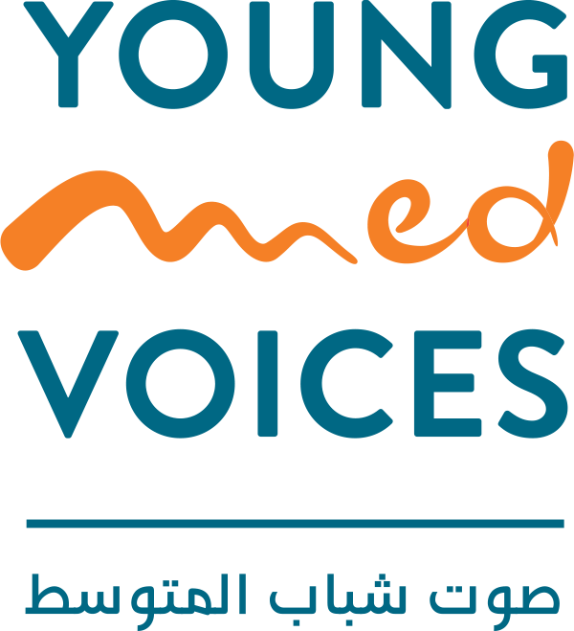

Info-Session

Co-funded by Co-organised by: In association with the European Union

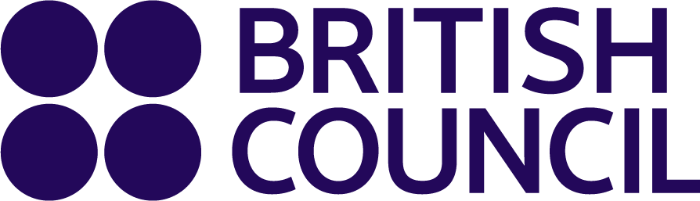 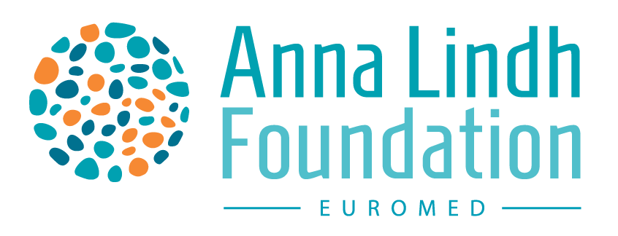  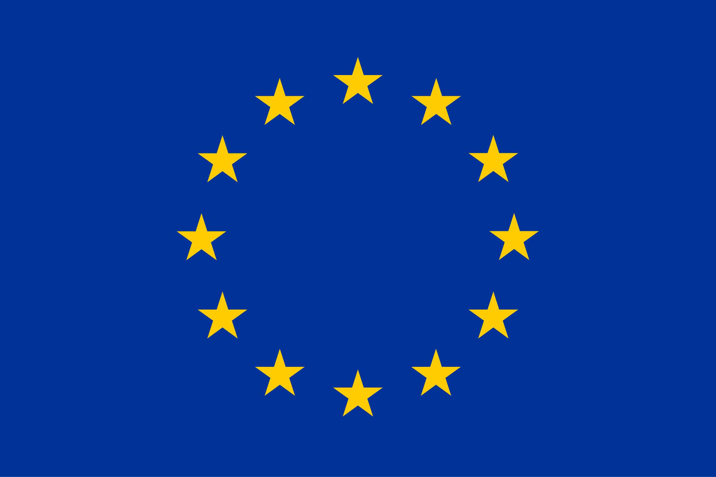

*e.g.2 Generic design*

Co-organised by:

 



Co-funded by

In association with: the European Union  

For any comms-related inquiries, please contact:

**Rahma Mida:**

Outreach and Project Support Officer – Young Mediterranean Voices Programme

[Rahma.Mida@tn.britishcouncil.org](mailto:Rahma.Mida@tn.britishcouncil.org)